World Bank Group Intermediate Committee Chair: Shelinna Chen
Co-chair: Jason Li

Topic 1: Relieving Poverty in Third-World Communities Introduction
Poverty and inequality have long shaped the world in complex ways. Those in poverty often live in inadequate environments, with incomplete infrastructures and shelters, insufficient income, and often lack basic food sources and clean water. In 2016, when the United Nations officially established the Sustainable Development Goals, ending poverty was identified as Goal
1. Addressing poverty remains one of the most crucial factors to address for a developing country to achieve sustainable growth. Thanks to the immense effort to reduce poverty, the total poverty headcount has declined from around 2.3 billion to around 831 million in the past decades. However, progress in poverty reduction is uneven. Some regions have seen rapid growth, while others are still trapped in lack of financial support.

Definitions

Poverty is defined differently in different regions but is generally understood as the state of
lacking fundamental financial and material resources.
Absolute poverty is any individual living below the extreme poverty line.

Relative poverty is a comparison which emphasizes the difference between the poorest and the
rest of the population.

Extreme poverty line is currently placed by the World Bank at $3.00 per person per day.

Third world is term that refers to many communities of heterogeneous societies, cultures, and
civilizations of the non-Western world which are not completely modernized and have low standards of living.

History
Poverty has historically been both a cause and a consequence of instability. Poverty and inequalities rooted in developing nations is constantly leading to civil unrest, regional conflicts and even war. At the same time, limited access to clean water, shelter, food, education, and income are trapping people in poverty.
In 1800, 81 percent of population worldwide were making less than $1.90 per day. 190 years later, the poverty population declines by almost half. From 1800-1850, poverty reduction remained at a similar rate, with approximately less than one percent decreases every 15 years.
Then, in the following 140 years, progress became much more rapid. For every four years, poverty rate fell by one percent. From around 1990 to 2020, the decline became even more quickly.
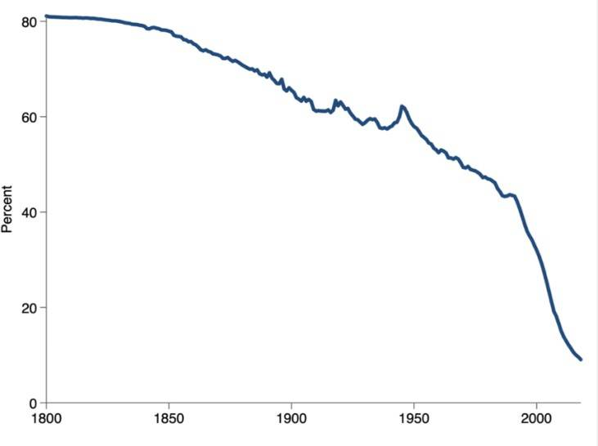

Figure 1 Percentage of poverty overtime

Current Situation
As of fall 2025, approximately one in ten people worldwide live in extreme poverty. In the past 35 years, the total poverty population dropped from around 2.3 billion to around 831 million. However, progress has slowed in the past 10 years. Areas such as Sub-Saharan Africa and places in conflict still suffer from extreme poverty. Currently, around three-quarters of the extreme poverty population live in rural areas. While mitigating these issues across the globe, there currently exists uneven progress among different regions. From 1990 to 2015, the poverty population concentration shifted from East Asia and Pacific to Sub-Saharan Africa. In 2015, over 85 percent of the total poverty population lived in Sub-Saharan Africa or South Asia. Currently, uneven progress to mitigate poverty continues to span across the world.

Questions to Consider

- What are the primary structural causes of poverty in third-world communities?
- What are some sustainable solutions to ensure basic food, water, and shelter access of communities in extreme poverty?
- What aspects of development (education, employment, healthcare, etc.) should communities in poverty prioritize?
- How can developed countries play a role in relieving poverty in third-world countries?

Bibliography
Bourassa, C. (2021). Absolute and Relative Poverty | Social Sciences and Humanities | Research Starters | EBSCO Research. EBSCO. https://www.ebsco.com/research-starters/social- sciences-and-humanities/absolute-and-relative-poverty
Homi Kharas, & Dooley, M. (2022, February 2). The evolution of global poverty, 1990-2030. Brookings. https://www.brookings.edu/articles/the-evolution-of-global-poverty-1990- 2030/
Owusu, M. (2015). Third World. International Encyclopedia of the Social & Behavioral Sciences, 300–304. https://doi.org/10.1016/b978-0-08-097086-8.12154-3
Rosnick, D. (2019, May 21). A History of Poverty Worldwide. Shorthandstories.com. https://cepr.shorthandstories.com/history-poverty/
The World Bank. (2023). Where in the world do the poor live? It depends on how poverty is defined. Worldbank.org. https://datatopics.worldbank.org/world-development- indicators/stories/where-do-the-poor-live.html
United Nations. (2025, June 19). Warning Two Thirds of Global Poor to Live in Conflict- Affected, Fragile States by 2030, Secretary-General Tells Security Council Development Gives Peace “Fighting Chance” | UN Meetings Coverage and Press Releases. Un.org. https://press.un.org/en/2025/sgsm22692.doc.htm?
World Bank Group. (2017). Overview. World Bank. https://www.worldbank.org/en/topic/infrastructure/overview
World Bank Group. (2025a, June 13). June 2025 Update to Global Poverty Lines. World Bank; World Bank Group. https://www.worldbank.org/en/news/factsheet/2025/06/05/june- 2025-update-to-global-poverty-lines

World Bank Group. (2025b, June 13). June 2025 Update to Global Poverty Lines. World Bank; World Bank Group. https://www.worldbank.org/en/news/factsheet/2025/06/05/june- 2025-update-to-global-poverty-lines
World Bank Group. (2025c). ONE IN TEN PEOPLE GLOBALLY LIVE IN EXTREME

POVERTY. https://thedocs.worldbank.org/en/doc/229ff18129687a785f08af7cfb28e5e1- 0350012025/original/WBG-Poverty-and-Inequality-Update-Fall-2025.pdf

Topic 2: Supporting Infrastructure and Societal Development in Developing Nations Introduction
Sustainable infrastructure can aid employment increase, economic growth, and quality of life. It provides an opportunity for countries to invest in projects that reduce carbon footprints and allow them to approach their climate and development goals. It plays a key role in working towards the Sustainable Development Goals. However, many developing nations face lack of infrastructure due to various reasons. It is estimated that to close the gap between current levels of infrastructure investment and the level to achieve the Sustainable Development Goals, it will cost around 18 trillion dollars by 2040.

History of conflict

Historical conflicts, colonization, and the Industrial Revolution have widened the gap between developed nations and developing nations. Many developing nations in Africa, Asia, and Latin America inherited infrastructure built by the colonial powers. These mainly included railways, ports, and roads that served for resource extraction and export instead of domestic development. Later, infrastructure expanded at expensive costs and sometimes poorly maintained. In the recent decades, globalization has led to growing foreign investments that have allowed developed nations to help build developing nations.

Current Situation

Currently, approximately one billion of the population worldwide reside over two kilometers from an all-season road (durable, engineered road that are passable throughout the year, regardless of weather conditions). Nearly four billion people live without access to the internet. The lack of adequate infrastructure services has generated costs of hundreds of billions of dollars per year on individuals and firms. In addition, the poorest and most fragile countries face the highest costs for broadband, electricity, and transportation services. World Bank has largely invested to help close infrastructure gaps and support development. Recently, infrastructure development was heavily environment related. Among developing countries, OECD has reported survey results of 69% countries have invested in infrastructure projects that are key to promoting sustainability; 59% have cross-sector synergies to minimize negative environmental impacts.

Key factors holding infrastructure development back are also common characteristics shared by many developing nations. In 2022, almost two-thirds of Least Developed Countries (LDCs) and Low-Income Countries are either in or at risk of debt distress (a situation when one is unable to pay off its debts). At the same time, many LDCs are also marginalized in term of trades. From 2010 to 2022, all LDCs combined only account for 1% of global merchandise exports. In addition, 69% of the deaths caused by climate disasters happened in an LDC, making them highly vulnerable to climate crisis.

Questions to consider

- What are policies and/or strategies developing nations should implement to prioritize infrastructure and societal development?
- How can infrastructure development align with the Sustainable Development Goals?

- How can developing nations address the existing challenges of infrastructure growth?
- What role do developed nations play in developing nations’ infrastructure and societal
growth?

Bibliography
OECD. (2026). Infrastructure. OECD. https://www.oecd.org/en/topics/policy- issues/infrastructure.html
United Nations. (n.d.). SDG indicator metadata (Harmonized metadata template -format version 1.0). https://unstats.un.org/sdgs/metadata/files/Metadata-09-01-01.pdf
United Nations. (2022, April 25). Debt, Affordable Finance, and a Future for the Least Developed Countries | Office of the High Representative for the Least Developed Countries, Landlocked Developing Countries and Small Island Developing States. Un.org. https://www.un.org/ohrlls/news/debt-affordable-finance-and-future-least- developed-countries
United Nations. (2025, September 10). Goal 9: Industry, Innovation and Infrastructure - United Nations Sustainable Development. United Nations Sustainable Development. https://www.un.org/sustainabledevelopment/infrastructure- industrialization/#:~:text=How%20much%20progress%20have%20we,Why%20should% 20I%20care
World Bank Group. (n.d.). Infrastructure. World Bank. Retrieved February 20, 2026, from https://www.worldbank.org/en/topic/infrastructure/overview
World Bank Group. (2023). The Impact of Infrastructure on Development Outcomes: A Qualitative Review of Four Decades of Literature. Worldbank.org. https://openknowledge.worldbank.org/entities/publication/7066b083-fb5f-4169-a863- 6ebf318e3e45
World Bank Group. (2025). Infrastructure. World Bank. https://www.worldbank.org/en/topic/infrastructure

