Stranger Things
Specialty Committee
Chair: Lauren Cockwell

Topic 1: Development of Psychic/Supernatural Weapon Programs
Introduction
In the quiet suburbs of Hawkins, Indiana, reality has been flipped upside down. What began as classified government research into the human mind and its capabilities has opened a gateway to forces beyond known science, exposing the world to the Upside Down and its catastrophic consequences. Psychic experimentation, supernatural weaponization, and the exploitation of vulnerable individuals have blurred the line between national security and moral responsibility. As governments race to understand, control, and in some cases exterminate, these phenomena, fear, secrecy, and uncertainty now shape global decision-making.
History
This committee convenes in a world where extraordinary abilities are no longer myths but strategic assets. Drawing inspiration from covert programs such as MKUltra, states have begun pursuing psychic and supernatural weapon initiatives with little oversight and unclear ethical limits. Telekinesis, mind manipulation, and altered consciousness promise unprecedented military power, yet their unpredictable nature threatens global stability. Delegates must confront whether such research can ever be safely regulated, or whether its very existence creates an imbalance that endangers humanity as a whole. The effects of these covert programs have shown destruction in Hawkins, and all around the world citizens fear what may result from them.

Current Situation
The concept of psychic and supernatural abilities has led governments to pursue classified weapon programs modeled after initiatives such as Project MKUltra. Some governments have begun exploring ideas and research far outside normal military science, focusing on abilities that many people do not fully understand. These programs often operate in secrecy, which makes it hard for the public to know what is real and what is speculation. People feel uneasy about the idea of psychic or supernatural abilities being used in conflict, especially when there are no clear rules or limits. This topic looks at the uncertainty surrounding these programs and how fear arises when governments explore something that exists between science and the unknown.

Questions to Consider:
- Should such programs be restricted, considering risks and potential global security imbalances?
- How can we establish international oversight, regulated experimentation, and defined ethical boundaries for research involving altered consciousness, telekinesis, or mind-manipulation technologies?
- How can states prevent the misuse of psychic weapons by rogue actors while still advancing scientific understanding?

Topic 2: Regulating Government Research Involving Children With Special Abilities
Introduction
The world as we know it no longer operates solely within the boundaries of conventional science. In recent years, the emergence of psychic abilities, interdimensional threats, and covert government experimentation have reshaped global security in ways that must be addressed. What was once dismissed as science fiction has become a matter of urgent international concern. The discovery of the Upside Down and the existence of individuals capable of manipulating matter, perception, and consciousness have forced governments to confront a new category of threat, one that blurs the line between scientific advancement and the unknown. As states struggle to maintain security in this unstable environment, secrecy has become the most prevalent response. Classified research facilities, unregulated experimentation, and covert weapon programs are everywhere, often without public knowledge or international oversight. While some argue that these initiatives are necessary to defend against supernatural threats, others warn that unchecked experimentation risks catastrophic consequences. When children are valued primarily for their abilities rather than their humanity, states risk crossing irreversible ethical boundaries. The international community must determine how to protect vulnerable individuals while acknowledging the real dangers posed by uncontrolled supernatural forces.
History
Hidden within Hawkins Laboratory, minors have been stripped of their autonomy, taken from their family, and subjected to experimentation, often against their will. These practices raise profound concerns about consent, psychological harm, and human rights. The most notable of these children, known as Eleven, demonstrated telekinetic and psychic capabilities far beyond previous expectations. However, these experiments also resulted in unintended consequences, including the accidental opening of a gateway to an alternate dimension known as the Upside Down. The Upside Down poses a new dimension of global risk. Hostile entities, environmental corruption, and psychological trauma spread beyond the laboratory, affecting civilians and destabilizing the region and world as we know it. As awareness of these events slowly expanded and spread, it became clear that psychic experimentation posed dangers not only to those directly involved but to society at large. The exploitation of children, the lack of safeguards, and the absence of international accountability raised serious ethical and legal concerns.
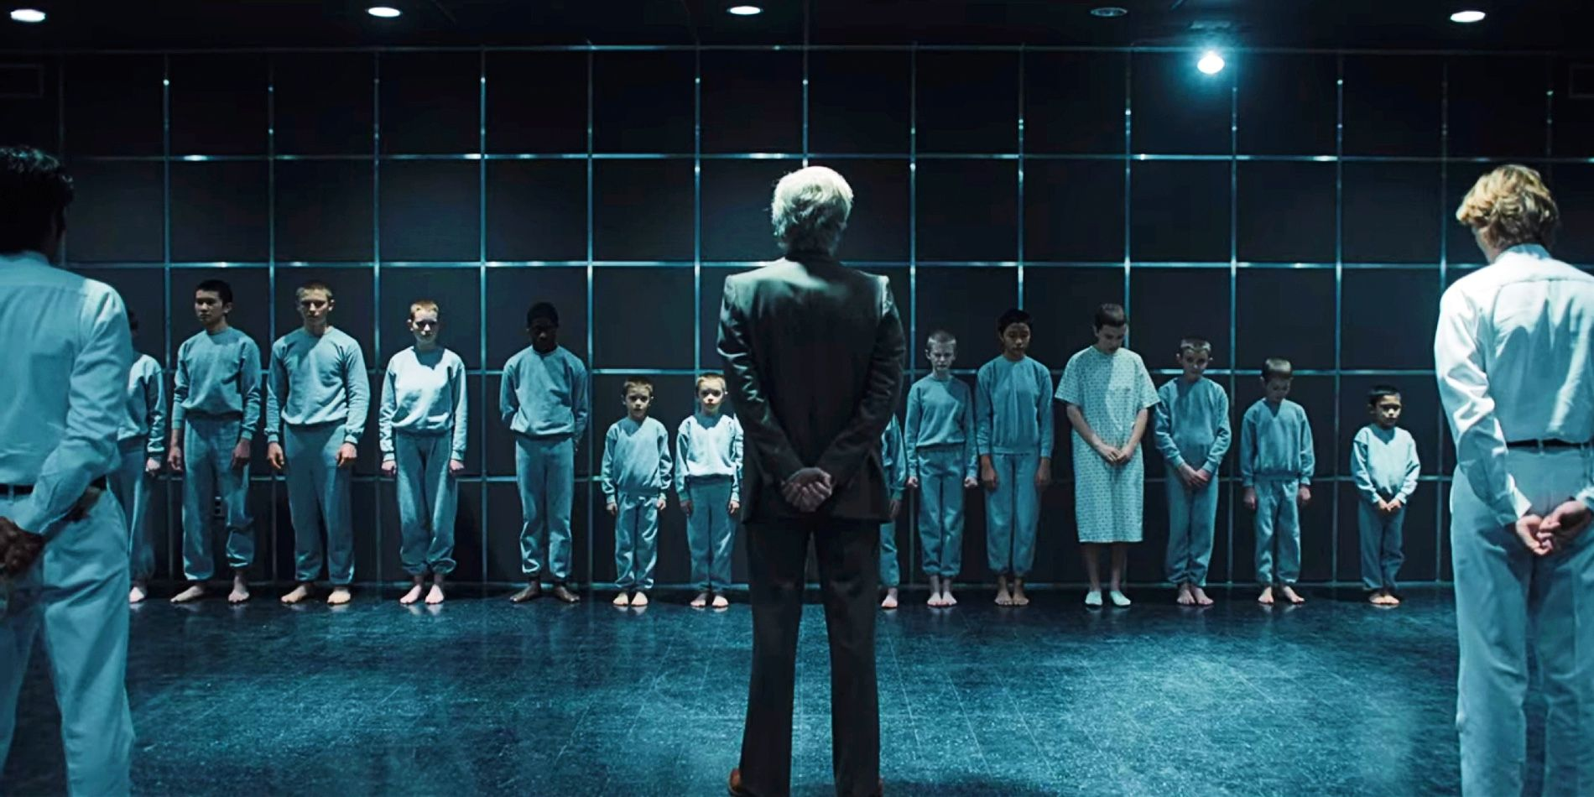
Current Situation
Today, governments face a critical crossroads. Psychic and supernatural abilities offer immense strategic potential, yet their misuse could lead to irreversible harm. Children with special abilities remain particularly vulnerable, caught between national-security interests and their fundamental human rights. This committee must evaluate how to regulate supernatural weapon development, protect minors from exploitation, and establish ethical boundaries for research, before secrecy and fear give rise to consequences even beyond what has already occurred. Children who exhibit rare or enhanced abilities typically become targets of secret government research programs, which raises significant concerns about consent, safety, and long-term psychological harm. Many of these children are too young to understand what is happening, and their families may feel pressure to agree to things they are unsure about. This brings up questions about what they can consent to, their emotional well-being, and whether these children are being valued for who they are or simply for what they are capable of. When abilities become the focus of a child’s worth, it is easy for people to forget the basic rights and needs of the child.
Questions to Consider
- What protections should be put in place to protect minors?
- Should regulations be imposed on experimentation, with rehabilitation programs and international monitoring of research facilities?
- How can governments balance national-security interests with their obligation to safeguard vulnerable populations?
- How can we prevent exploitation while acknowledging the unique security implications that powerful supernatural abilities might pose to society?
Works Cited
Encyclopedia Britannica. (2026, January 23). Stranger things. https://www.britannica.com/topic/Stranger-Things
Everything Explained Today. (n.d.). Stranger things explained. https://everything.explained.today/Stranger_Things/
ScreenRant. (2022, June 7). Explosive stranger things theory reveals eleven's real father. https://screenrant.com/stranger-things-eleven-father-vecna-henry-creel-theory/
ScreenRant. (2022, June 16). Why eleven forgot her memories of number 1 & Hawkins lab. https://screenrant.com/why-eleven-forgot-number-1-hawkins-lab-memories/
Wikipedia. (2025, October 8). Stranger things. Wikipedia, the free encyclopedia. https://en.wikipedia.org/wiki/Stranger_Things

