International Labour Organization
Novice Committee
Chair: Kevin Jing

Topic 1: Improving Workplace Safety Standards in High-Risk Industrial Sectors
Introduction
In 2023 reports conducted around the world involving 142 countries declared that 3 million people died in workplace accidents white 395 million sustained non-fatal injuries. The biggest contributors to high injury rates is the high-risk industrial sectors including the likes of mining, fishing, and construction all of which has around a 20% chance of injury (Engineering Safer Workplaces: Global Trends in Occupational Safety and Health, 2024). High Risk Industrial Sectors are the backbones of many economies and businesses, which establishes their importance in the global supply chain. It is thus essential to improve standards in which the mortality and injury rates decrease.

Context
4 main threats in the high-risk industrial sector have caused the industry to have the highest and most disproportionate mortality rate among all jobs, accounting for 63% of global fatal occupational injuries (International Labour Organization, 2023). Firstly, The High-Risk Sector includes jobs that range from operating high-voltage electrical generators to unclogging oil pipelines atop offshore oil rigs, all of which possess differing scenarios of injury and death, which in turn increases the risk of accidents and health issues. Secondly, on a more concerning note, companies often take cost cutting measured, cutting budgets for safety regulations and education. Insufficient training and bare-minimum safety standards further increase the likelihood of accidents. Thirdly, companies in high-risk industries have consistently sought to undermine labour unions. In the mining industry, companies have repeatedly tried to break unions that fight for better wages, improved safety, and greater government oversight. Lastly, many countries’ governments lack strict and clear regulations for companies to follow, meaning they are left with employers that don't have proper guidance and employees that will not receive protection and justice.
These problems date back to the 1900s, stemming from worker exploitation and labour injustices caused by big companies, robber barons, and trusts. With the creation of the United Nations following the Treaty of Versailles, the allies sought to raise working standards across all industries, thereby establishing the International Labour Organization (ILO). The ILO now serves as a UN agency that sets standards for work environments and worker rights, bringing together governments, employers, and workers to uphold these rights.

Current situation
Although compared to the past, there has been a decrease in accident rates, High-Risk industries still see a disproportionate number of injuries. From 1980 to 1984, USA’s CDC organization collected data that showed decreasing mortality death rates of all industries but highlighted the enormous gap between other occupations and high-risk industries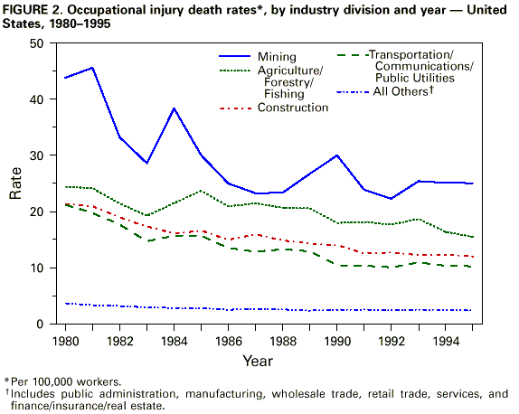
(CDC, 2019)
The world is now facing a job crisis in the high-risk industry sector because of ongoing safety concerns. The growing demand for labour in these jobs creates serious issues worldwide, as industries like mining are the backbone of the energy sector and crucial to producing consumer products. With increasing demand in the job market, countries have looked abroad, particularly to Asia, to attract cheap labour and boost exports. However, these cheap exports come at a high cost, as worker regulations and protections are often severely diminished. This sometimes results in the hiring of underpaid, inexperienced, and underage workers.

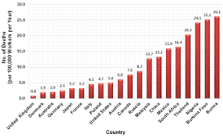
(Zaria, n.d.)
Beyond these economic and regulatory issues, workers in the high-risk industrial sector face daily exposure to hazardous substances such as toxic chemicals, dust, and fumes, which can lead to long-term health complications, including respiratory diseases, cancers, and other chronic conditions. The use of heavy and sometimes outdated machinery increases the risk of severe injuries or fatalities due to equipment malfunction or human error. Many job sites lack adequate safety infrastructure, such as proper ventilation, protective gear, and emergency response systems, further endangering workers.

Questions to Consider
- How can governing bodies intervene in a way so that these issues wouldn’t be damaging to the global economy?
- To what extent should the company take responsibility for personal injuries that aren’t clearly addressed under a country’s laws?
- If accident rates decrease in the industry how can companies communicate that to the public to increase job demand for the industrial sector?
- How can governments enforce safety compliance more effectively in industries where accidents are frequent?
- How should companies conduct risk assessments to identify potential safety hazards in their operations?
- How can collaboration between companies and safety organizations lead to better outcomes for worker safety?

Topic 2: Eliminating Modern Slavery in Global Supply Chains
Introduction
Forced labour and modern slavery remain pressing issues that affect vulnerable populations worldwide, particularly within complex international supply chains. Forced labour and modern slavery are extremely pressing issues nowadays, happening all over the world and commonly in Asian countries. Individuals often coming from marginalized communities and rural areas more often find themselves trapped in exploitative conditions, being forced to work in hazardous environments for minimal pay that leaves no room for financial mobility, essentially forcing workers into a modern form of slavery. The complex global supply chains seen in the world now complicate efforts to pinpoint these abuses, as international companies fail to gain visibility into the lower tiers where these illegal practices frequently occur

Context
Forced labour and modern slavery are deeply tied to economic, social, and political factors that negatively impact vulnerable populations, especially regarding global supply chains. Companies now outsource tasks and supply chains to other countries, seeking cost efficiency, and in turn obscure the conditions under which workers work. Three main threats can be identified.
- The abuse works, as these jobs tend to attract disadvantaged communities that lack resources and support to assert their rights and protection. In many regions, systematic poverty, lack of education and limited access to legal protection create this vulnerability that can be easily exploited by employers.
- Vulnerable populations, including women, children, and migrant workers, are often lured by false promises of employment and better living conditions. Once they arrive, they might be encountered with unsafe environments, excessive working hours and abusive practices, including debt bondage, and threat of violence. For example, the UAE is a bustling metropolis filled with skyscrapers and bustling economic zones. What is ignored however, is the fact that almost all the city expansions and new construction projects are built with Asian immigrants that where lured to Dubai and other emirates with the illusion of a better life but instead face inhuman and abusive living conditions.
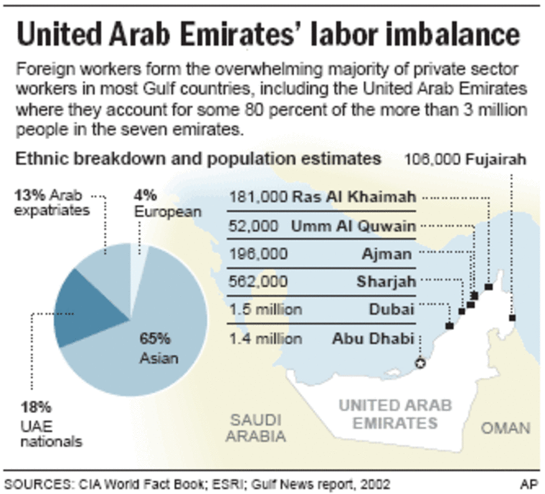
(Redirect Notice, 2026)
- Additionally, the ongoing globalization of trade has created an environment in which companies tend to prioritize profits over ethical labour practices. Sometimes turning a blind eye to the realities of their international supply chains. Sometimes, however, it is not entirely the company's fault, as they may lack political will or resources to enforce labour laws effectively, further complicating labour exploitation.

Current Situation
In 2025, forced labour remains a massive issue worldwide, exacerbated by economic instability, supply chain disruptions, and ongoing geopolitical tensions. After the COVID-19 pandemic, global supply chains were damaged, causing economic strain on individuals and companies, particularly in developing countries. As demand on the job market increases, individuals scramble in search of jobs, thus opening up allow companies to take advantage and lure desperate populations into exploitive jobs. The current situation surrounding forced labour and modern slavery presents both challenges and opportunities for change. While the situation right now is grim, exploitation, increased awareness, legislative efforts, corporate accountability mechanisms, and technological advancements offer pathways to effectively combat these issues. Addressing the factors that surround modern slavery requires a collaborative and maintained effort from governments, businesses, and society, emphasizing the urgent need for comprehensive measures to protect vulnerable workers worldwide.

Questions to Consider
- How can governments restrict the collusion and lobbying between companies and lawmakers to prevent unfair regulations that negatively affect workers?
- What specific measures can companies take to make sure ethical labor practices are used throughout their supply chains?
- How can rural and local communities be empowered to combat forced labor and advocate for workers’ rights?
- How can progress be monitored and reported to ensure that appropriate actions are taken to address forced labor issues?
- What trends or shifts in global trade might affect the prevalence of forced labor in the future?

Work Cited
Anti-Slavery International. (2025). What Is Modern Slavery? Anti-Slavery; Anti-Slavery International. https://www.antislavery.org/slavery-today/modern-slavery/
Beattie, S. (2025, May 30). Hamilton steel processing company fined $200K after death of worker hit by forklift. CBC. https://www.cbc.ca/news/canada/hamilton/janco-steel-fine- worker-death-1.7548331
Bureau of Labor Statistics. (2023). National Census of Fatal Occupational Injuries in 2022. https://www.bls.gov/news.release/pdf/cfoi.pdf
CDC. (2019). Achievements in Public Health, 1900-1999: Improvements in Workplace Safety -- United States, 1900-1999. CDC.gov. https://www.cdc.gov/mmwr/preview/mmwrhtml/mm4822a1.htm
Engineering Safer Workplaces: Global trends in occupational safety and health. (2024, October 22). Lloyd’s Register Foundation. https://www.lrfoundation.org.uk/publications/engineering-safer-workplaces-global- trends-in-occupational-safety-and-health?_gl=1
Higher risk of work injuries found among those in precarious jobs: IWH study. (2024, February 13). Iwh.on.ca. https://www.iwh.on.ca/plain-language-summaries/higher-risk-of-work- injuries-found-among-those-in-precarious-jobs-iwh-study
International Labour Organization. (2023, November 26). Nearly 3 million people die of work- related accidents and diseases | International Labour Organization. Www.ilo.org. https://www.ilo.org/resource/news/nearly-3-million-people-die-work-related-accidents- and-diseases
Laborers riot over low Dubai wages. (n.d.). NBC News. https://www.nbcnews.com/id/wbna11961753
Mining and quarrying named among the most dangerous occupations in the world. (2024, October 22). Lloyd’s Register Foundation. https://www.lrfoundation.org.uk/news/mining- and-quarrying-named-among-the-most-dangerous-occupations-in-the-world
Redirect Notice. (2026). Google.com. https://www.google.com/url?sa=i&url=https%3A%2F%2Fwww.nbcnews.com%2Fid%2F wbna11961753&psig=AOvVaw1RxAipaJbKIV555ZPaf8zE&ust=1771637532402000&s ource=images&cd=vfe&opi=89978449&ved=0CBUQjRxqFwoTCIDtzJ_25pIDFQAAA AAdAAAAABAE
Zaria, U. A. (n.d.). Work-related fatality rate for 20 countries in 2003. Researchgate. https://www.researchgate.net/figure/Work-related-fatality-rate-for-20-countries-in-2003- data-extracted-from-5_fig1_320409434

