European Union (EU) Committee ACMUN 2026
Intermediate Committee
Chair: Joshan Chopra

Delegate Countries: Austria, Belgium, Czechia, Croatia, France, Germany, Hungary, Italy, Ireland, Netherlands, Poland, Portugal, Spain, Sweden, Slovakia

Topic 1: Potential Improvements Toward Eurozone Economic Stability

Introduction

The Eurozone is one of the most important economic unions in the world. It includes 21 member states of the European Union (EU) that use the euro as their official currency.

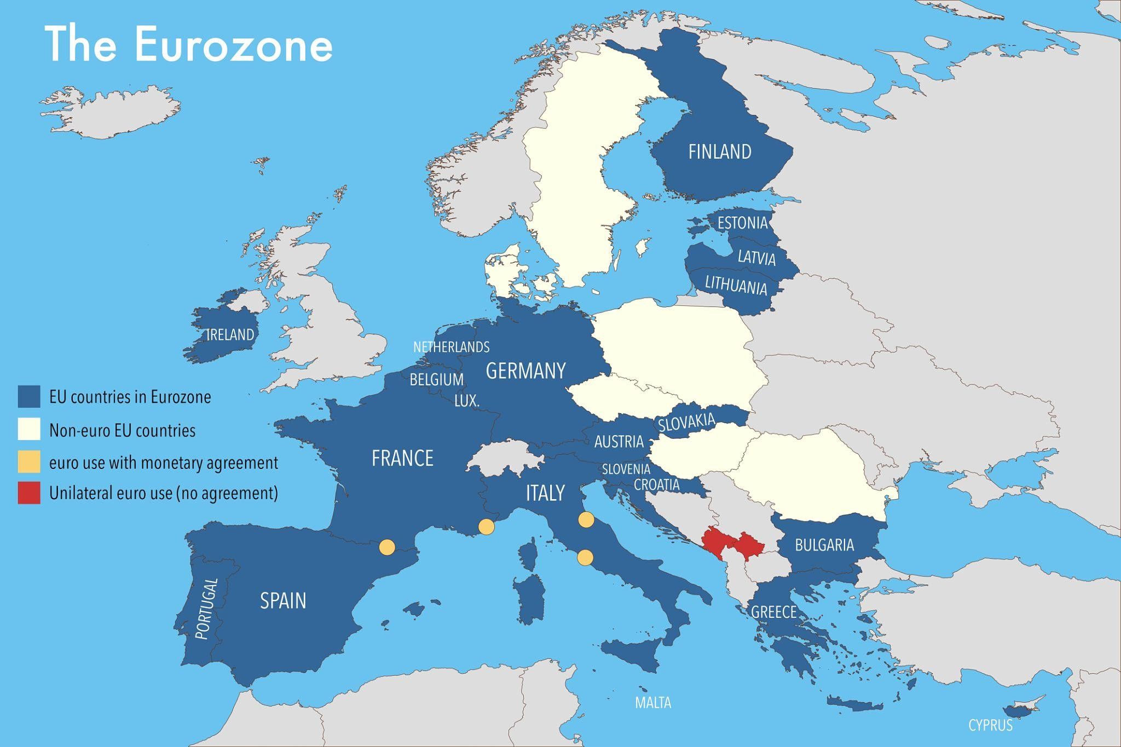
The Eurozone increases economic cooperation and aids trade. It also eliminates exchange rate problems and fosters stronger political unity among its members. This arrangement makes travel and trade easier because consumers can compare prices of goods and services, and businesses do not have to worry about cross-border exchange rates.
However, since the Eurozone runs a single monetary policy but has separate national budgets, economic problems in one country can spread quickly to banks and markets in other nations. Some Eurozone countries have stable finances and strong export sectors, such as Germany and the Netherlands. On the other hand, countries such as Italy, Greece, Portugal and Spain struggle with high debt, slow economic growth, and high unemployment. Since countries cannot control interest rates or the devaluation of their currencies, they have to balance cooperation with other countries and economic independence during crises.

Definitions

European Central Bank (ECB): The central bank that controls monetary policy for the Eurozone, including setting interest rates and controlling inflation.

Monetary Policy: The strategy and actions that the central bank takes to achieve and manage inflation and economic growth.

Fiscal Policy: The use of government spending and taxation to affect a nation's economy.

Sovereign Debt: The money borrowed by a national government.

Stability and Growth Pact (SGP): EU rules designed to ensure public finances are sound and economic growth is stable (ie, limits deficits to 3% of GDP and debt to 60% of GDP).

European Stability Mechanism (ESM): A conditional financial assistance fund (including loans and credit lines) for Eurozone countries facing severe financial problems (maximum lending capacity of €500 billion).

International Monetary Fund (IMF): An organization made up of 191 nations that monitors the global economy, loans money, provides advice, and supports countries to help them avoid and recover from financial struggles.
Banking Union: Established in 2014, it is an EU-level framework designed to ensure bank safety and stability, and to provide unified supervision.

History of Conflict

The euro was introduced in 1999, and it initially served as a symbol of European unity. However, over time, differences in the economies of the various countries became more obvious. Some nations had very large debts, while others had better financial control.
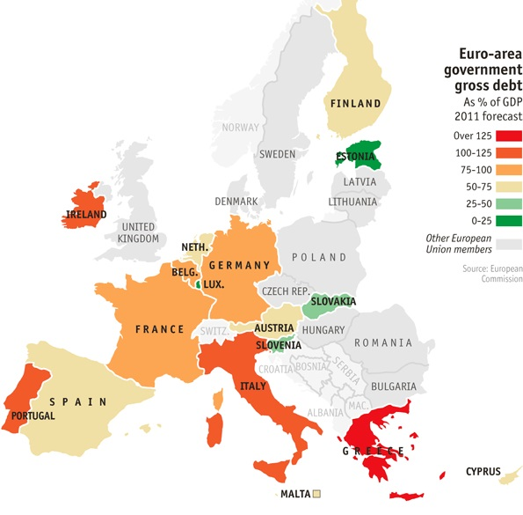
In 2008, the situation got worse during the global financial crisis, when the economic decline led to lower tax revenues and an increase in government spending. For example, by 2009-2010, Greece’s government debt was actually much higher than it had previously reported. The country struggled to borrow money at affordable rates when investors lost confidence in its ability to repay loans, and therefore, borrowing became more expensive (Lane, 2012).
Greece needed financial support from other EU countries and the International Monetary Fund because it could not print its own money or devalue its currency. The country was forced to lower public spending, raise taxes, and reduce wages in exchange for financial support, which led to unemployment, protests, and political instability (Feathersone, 2015).

Countries like Ireland, Spain, and Portugal also needed assistance. The Eurozone had a common monetary system and was economically connected. But the crisis revealed a lack of a large, shared fiscal system and political divisions over who would take responsibility for an economic bailout. In response, the EU strengthened financial management and bank supervision by creating the Banking Union and establishing the European Stability Mechanism to provide emergency loans (Allard et al., 2013).
In 2020, when the COVID-19 pandemic caused another major economic shock, leaders created the NextGenerationEU (NGEU) recovery fund. The EU borrowed €750 billion for the first time to collectively support all its member states (European Commission, 2020). This fund would help countries repair economic and social damage caused by the pandemic by offering grants and loans. This marked an important step toward greater financial cooperation between EU nations and changed expectations about what the EU might do in future crises.

Current Situation
Today, the Eurozone still faces multiple economic pressures. In 2022, following Russia’s invasion of Ukraine, inflation increased due to supply chain disruptions and rising energy prices (European Central Bank, 2022). To reduce inflation, the European Central Bank increased interest rates (European Central Bank, 2023).
However, higher interest rates also raise borrowing costs for countries, and since the same interest rate applies across the euro area, the impact depends on each country’s debt level and growth rate. For countries with high debt, such as Italy and Greece, refinancing old debt becomes more expensive and thus causes more economic pressure.
The Stability and Growth Pact rules have come back into focus with the European Commission proposing a new governance framework to strengthen the sustainability of debt while promoting growth through investments (European Commission, 2024). Some countries believe the SGP rules must maintain trust and fiscal stability, while others are pushing for more flexibility to allow for investment in long-term growth. The economic inequality between southern and northern Europe continues to be of concern (Bennigsen & Zuba, 2019). The main challenge for this committee is to strengthen the stability of the Eurozone’s monetary system so that it can absorb shocks and prevent local problems from escalating into broader regional crises.

Questions to consider:

How can the EU balance fiscal discipline with economic growth?

Should the Stability and Growth Pact be reformed?

How can a financial crisis in one member state be prevented from affecting others?

How can economic gaps between northern and southern Europe be reduced?

For Non-Euro delegations, what responsibilities should they take on in Eurozone stability debates?

Bibliography
Allard, C., Koeva Brooks, P., Bluedorn, J. C., Bornhorst, F., Christopherson, K., Ohnsorge, F., & Poghosyan, T. (2013). Toward a fiscal union for the euro area (IMF Staff Discussion Note No. SDN/13/09). International Monetary Fund. https://www.imf.org/external/pubs/ft/sdn/2013/sdn1309.pdf
Bennigsen, L., & Zuba, M. (2019). Divergence and diversity in the euro area (RP 6/2019). Stiftung Wissenschaft und Politik. https://www.swp-berlin.org/10.18449/2019RP06/
European Central Bank. (2022, March). Economic Bulletin Issue 2/2022. https://www.ecb.europa.eu/press/economic-bulletin/html/eb202202.en.html

European Central Bank. (2023). Monetary policy decisions. https://www.ecb.europa.eu/press/pr/date/2023/html/ecb.mp231214~9846e62f62.en.html

European Commission. (2020). The EU’s recovery plan. https://commission.europa.eu/strategy-and-policy/recovery-plan-europe_en
European Commission. (2024). New economic governance framework. https://economy-finance.ec.europa.eu/economic-governance-framework/what-economic-governance-framework/evolution-eu-economic-governance/new-economic-governance-framework_en

Featherstone, K. (2015). External conditionality and the debt crisis: The ‘Troika’ and public administration reform in Greece. Journal of European Public Policy, 22(3), 295–314. https://researchonline.lse.ac.uk/id/eprint/63379/1/External%20conditionality%20and%20the%20debt%20crisis.pdf

Lane, P. R. (2012). The European sovereign debt crisis. Journal of Economic Perspectives, 26(3), 49–68. https://www.aeaweb.org/articles?id=10.1257/jep.26.3.49

Topic 2: Transitioning Away From Russian Oil and Gas

Introduction

The affordability of Russian oil and natural gas and its extensive pipeline network resulted in economic and political risks by increasing EU member states’ dependence on Russian energy imports (European Parliament, 2023). When political tensions between Europe and Russia increased, energy supplies became a powerful tool of influence. After Russia invaded Ukraine in 2022, energy dependence turned into a security issue. The EU, therefore, responded with restrictions and a commitment to reduce its dependence on Russia’s fossil fuels (European Commission, 2025).

How can the EU transition away from Russian oil and gas while still protecting its industries, maintaining economic stability, and advancing its climate goals? Energy runs homes, factories, transport and power generation. Cutting the supply too fast can cause a spike in prices, but moving too slowly can keep Europe vulnerable (European Parliament, 2023).

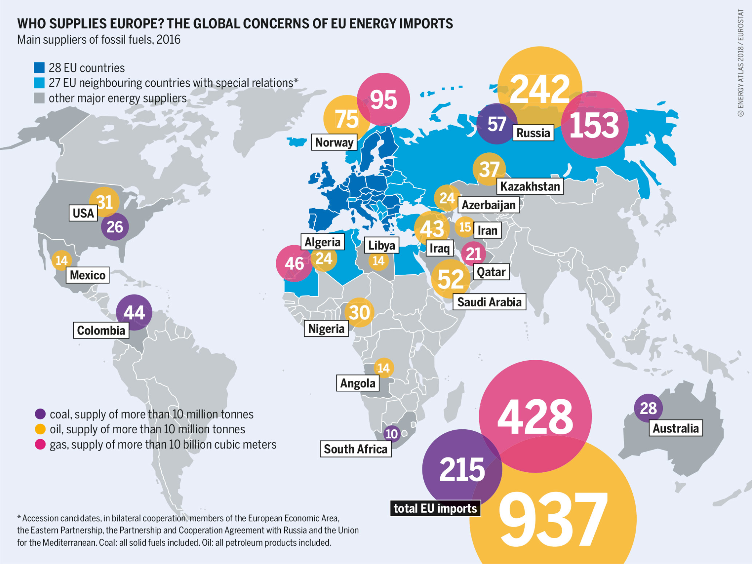

Definitions

Energy Security: The availability of energy sources at an affordable price, ensuring a reliable, efficient and sustainable supply to meet the demands of people’s lives.

REPowerEU: The EU’s comprehensive strategy launched in 2022 to rapidly reduce dependence on Russian energy imports by diversifying supply and expanding renewable green energy.

Liquefied Natural Gas (LNG): Natural gas (primarily methane) that has been cooled into liquid form, reducing its volume by ~600 times, allowing for safe transport by ship.

Energy Diversification: The strategy of increasing alternative sources of energy used to meet a country's energy needs, therefore reducing the dependence on a single supplier or limited sources of energy.

European Green Deal (EGD): The EU’s growth strategy and policy framework launched in 2019, with the goal of transforming the EU into a resource-efficient economy and legally binding it to achieve climate neutrality by 2050.
Regulation(EU) 2026/261: A legally binding EU regulation that transforms the REPowerEU strategy into a mandatory law and establishes a framework to phase out imports of Russian natural gas until completely eliminated by 2027.

History of Conflict

Before 2022, Russia provided around 40% of the EU’s natural gas imports (International Energy Agency, 2022). To import gas directly from Russia, many countries, such as Germany, built infrastructure, including the Nord Stream pipelines. In 2014, after Russia annexed Crimea, concerns about overdependence on Russia were raised, but imports continued. It was when Russia invaded Ukraine that energy became a central issue, and the EU moved swiftly to introduce restrictions, while Russia reduced gas deliveries, causing a sharp rise in energy prices and increased costs for European industries and households (Fella, 2022).

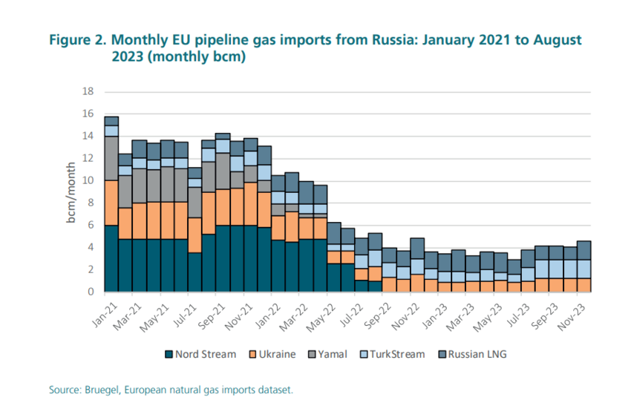

Depending on the extent of their reliance on Russian oil and gas, each country responded differently to the sudden price inflation. France and Spain expanded renewable energy production (International Energy Agency, 2022), while Germany built LNG terminals to import gas from other suppliers, such as the United States (Strupczewski, 2022). However, due to geographic and infrastructure constraints, some countries, such as Slovakia and Hungary, remained dependent on pipeline gas.
In May 2022, the EU responded to the crisis by launching the REPowerEU plan to end the dependence on Russian fossil fuels by focusing on increasing energy efficiency, diversifying energy sources and expanding renewable energy (Tagliapietra, 2022).

The EU also prohibited the marine transport of Russian crude oil and refined petroleum products to non-EU countries and restricted related services, such as technical assistance and financial support. In addition, the EU worked closely with the United States and other partners to increase LNG supply to Europe, helping them replace lost Russian pipeline gas (Keypour, 2022).

Current Situation
Since 2022, Russian gas imports have been significantly reduced and replaced with LNG imports from Norway, Qatar, and the United States (International Energy Agency, 2023), dropping from around 40% in 2021 to approximately 13% in 2025 (Council of the European Union, 2025). The EU has also increased renewable energy production, especially from wind and solar power.
Despite these measures, many challenges remain. Energy prices are still unpredictable, some industries face a slowdown in production due to high costs, and households in lower-income countries struggle with energy bills. Some countries increased coal use temporarily to prevent shortages in the short term, which conflicted with the EU’s climate goals (European Commission, 2025).
On February 2, 2026, the EU published Regulation(EU) 2026/261 to confirm the end of Russian gas imports (both pipeline and LNG) and the full phase-out of Russian oil, starting on March 18, 2026. It is a binding legal framework with fixed deadlines, aiming for full prohibition by the end of 2027 (European Parliament, 2025).

The committee must consider how to balance economic stability, energy independence, and environmental responsibility. If gas supply is stopped quickly, some countries might face supply shortages or higher prices. If the EU builds new LNG infrastructure, that can raise questions about locking in fossil fuel use for longer than preferred by climate policy.

Questions to consider:

What steps can the EU take to finance renewable energy expansion fairly?

Should the EU consider coordinating energy purchases at a regional level?

What kind of protections can the EU provide to industries affected by high energy prices?

How can energy solidarity between member states be strengthened?

How can climate goals be maintained during short-term energy challenges?
- To completely replace Russian gas imports, how should the EU handle countries that say they cannot pivot fast due to geography or infrastructure?

Bibliography

Council of the European Union. (2025, October 20). Council agrees its position on rules to phase out Russian gas imports under REPowerEU (Press release No. 842/25). https://www.consilium.europa.eu/en/press/press-releases/2025/10/20/council-agrees-its-position-on-rules-to-phase-out-russian-gas-imports-under-repowereu/

European Commission. (2025, May 16). REPowerEU 3 years on: Commission takes stock of progress to phase out Russian fossil fuels. https://energy.ec.europa.eu/news/repowereu-3-years-commission-takes-stock-progress-phase-out-russian-fossil-fuels-2025-05-16_en

European Parliament. (2023, September). Energy security: Solutions to today’s challenges. https://www.europarl.europa.eu/topics/en/aarticle/20230915STO05212/energy-security-solutions-to-today-s-challenges
European Parliament. (2025, December). EU to phase out imports of Russian gas. https://www.europarl.europa.eu/news/en/press-room/20251211IPR32169/eu-to-phase-out-imports-of-russian-gas

Fella, S. (2022). The EU response to the Russian invasion of Ukraine. https://researchbriefings.files.parliament.uk/documents/CBP-9503/CBP-9503.pdf

Keypour, J. (2022). Replacing Russian gas with that of the United States: A critical analysis from the European Union energy security perspective. Russian Journal of Economics, 8(2), 189–206. https://doi.org/10.32609/j.ruje.8.78026

International Energy Agency. (2022). A 10-point plan to reduce the European Union’s reliance on Russian natural gas. https://www.iea.org/reports/a-10-point-plan-to-reduce-the-european-unions-reliance-on-russian-natural-s
International Energy Agency. (2022). Renewable energy market update 2022. https://www.iea.org/reports/renewable-energy-market-update-may-2022
International Energy Agency. (2023). Policy response to the crisis – Gas Market Lessons from the 2022-2023 Energy Crisis – Analysis - IEA. IEA. https://www.iea.org/reports/gas-market-lessons-from-the-2022-2023-energy-crisis/policy-response-to-the-crisis
Strupczewski, J. (2022, June 3). Factbox: EU’s 6th sanctions package against Russia, including oil. Reuters. https://www.reuters.com/markets/europe/eus-6th-sanctions-package-against-russia-including-oil-2022-06-03/
Tagliapietra, S. (2022). REPowerEU: Will EU countries really make it work? (n.d.). Bruegel | the Brussels-Based Economic Think Tank. https://www.bruegel.org/blog-post/repowereu-will-eu-countries-really-make-it-work

