The Rise to Space United Nations Commission
Specialty Committee
Chair: Jai Singhal
Topic 1: Managing Corporate Militarization of Outer Space
Introduction
In 2080, outer space is no longer a distant afterthought, but the economic forefront for humanity. What began in the early 2020s as experimental lunar missions by NASA has transformed into established orbital cities, asteroid-mining colonies and privately owned corporate defensive systems. These private corporations now launch more satellites yearly than their governments do. With many owning private security fleets protect mining claims, data relays, and transport routes between Earth, the Moon, and Mars.
These developments have worried governments and have created a power vacuum outside of our atmosphere. The legal frameworks that once existed, specifically the 1967 Outer Space treaty always assumed that states would be the primary controllers of space. Not imagining trillion-dollar companies fielding weaponry or negotiating leases on asteroids. As the corporate powers square off against nations, questions have emerged of Who enforces law in orbit? Can a company declare a security exclusion zone? What prevents a private war beyond Earth? The committee must design some kind of guideline to manage the corporate militarization while preserving peaceful exploration and economic innovation in space.

History
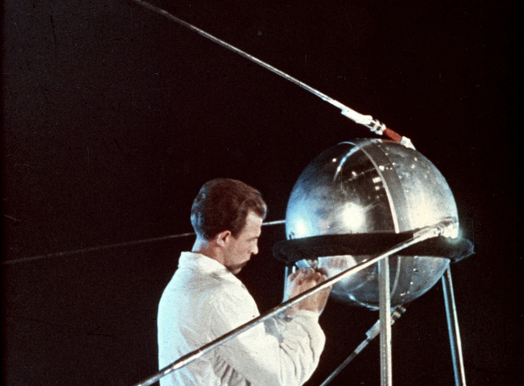
During the Cold War, the foundations were laid for humanities ventures into space. The launch of Sputnik (1957) enabled the fear in humanity that space would become the next battlefield. Birthing space laws in 1967 with the Outer Space Treaty establishing space as a “province for all mankind”, which hence banned weapons of mass destruction in orbit and making states responsible for the actions of their private companies. Into the 1990s however, space became heavily militarized through reconnaissance and navigation satellites, yet formal weaponization was largely avoided. In the early 2020s, private companies became more dominant, companies like SpaceX, Blue Origin had replaced governments as primary launch providers and Mega-constellations such as Starlink created privately owned global communications grids. Some countries including China in 2007, India in 2019, and even Russia in 2021 tested their anti-satellite weapons. By 2025, experts warned that corporations would soon require armed protection for space assets, yet no treaty addressed private military activity in space. Throughout the mid-twenty-first century, corporations began to expand their private security systems and dual-use technologies that blurred the line between defense and warfare. By the 2060s, companies had controlled transport routes and orbital infrastructure, and by 2080 their forces rivaled national militaries, while no international authority existed to regulate their actions.
A technician working on the satellite Sputnik 1. Credit: Sovfoto/UIG via Getty Images

Current Situation/Discussion (2080)
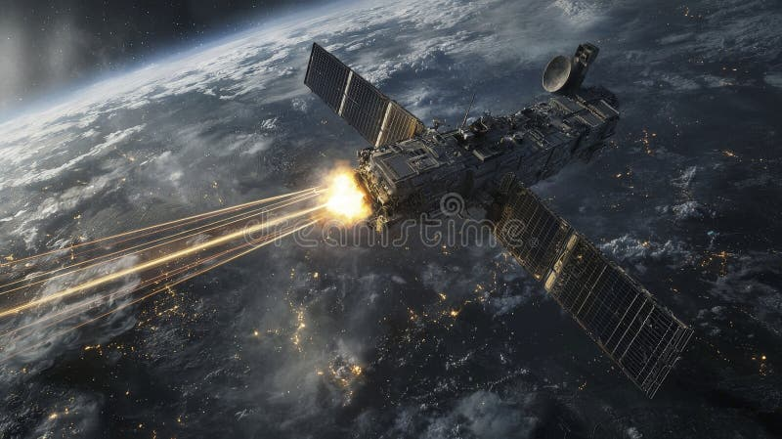
Now, the solar system has become a collection of companies/corporations that have majority holdings in the infrastructure and lunar bases in space. While laws still hold governments accountable for the actions of their corporations. Governments really have little actual authority over companies dominating millions of kilometers from Earth. Moreover, the global economy has become heavily dependent on these corporations that provide satellites that supply energy grids, medicine, and advanced manufacturing, which gives companies an enormous political leverage over governments. Simultaneously, there is no court, body, force or movement existing beyond Earth orbit to resolve disputes or prevent violence. Most concerning, the technology is dual-use-meaning systems designed for debris removal, transport, or navigation can be converted into weapons within minutes, making intentions difficult to judge. This unsettling combination of corporate power, legal uncertainties and risk has created an environment that threatens international peacetime and the futures of exploration in space.
Satellite weapons systems targeting earth from space futuristic sci-fi scene nighttime high-tech environment. A powerful satellite weapon system fires beams at targets on Earth showcasing advanced technology in a dramatic space setting

Some Questions to Consider
- Should corporations be allowed to maintain armed security forces in space?
- How can Article VI of the Outer Space Treaty be enforced in 2080?
- Is a UN licensing body for corporate defense necessary?
- How can dual-use technologies be monitored?
- What tribunal should judge crimes deep in space?
- Who owns asteroid resources: companies or states?

Bibliography
Boley, A. C., & Byers, M. (2021). Satellite mega-constellations create risks in low Earth orbit, the atmosphere and on Earth. Scientific Reports, 11(1). https://doi.org/10.1038/s41598-021-89909-7
Goh, G. M. (2020). Softly, softly catchee monkey: Informalism and the quiet development of international space law. Nebraska Law Review, 99(3), 725–782.
Secure World Foundation. (2022). Global counterspace capabilities: An open-source assessment. https://swfound.org/counterspace
Tronchetti, F. (2019). Legal aspects of space resource utilization. Journal of Space Law
United Nations. (1967). Treaty on principles governing the activities of states in the exploration and use of outer space, including the Moon and other celestial bodies. https://www.unoosa.org/oosa/en/ourwork/spacelaw/treaties/outerspacetreaty.html
United Nations Office for Outer Space Affairs. (2023). Reducing space threats through norms, rules and principles of responsible behaviors. https://www.unoosa.org
Weeden, B., & Samson, V. (2022). Global counterspace capabilities: An open-source assessment. Secure World Foundation.

Topic 2: Resource Rights on Asteroids and Exoplanets
Introduction
The 21st century turned outer space from a scientific perspective into possibly the most valuable resource depot in human existence. Asteroids that were rich in platinum, iridium, and water, along with several different minerals that existed on distant exoplanets, now have the potential to provide energy, construction materials and lifesaving technologies. However, unlike the oceans of the Earth. There is no clear system which proves to govern who may lay claim and profit from these regions. Only a handful of nations have the technology to reach them, which most can only watch from the ground. Without synonymous rules, space could become an area of economic colonialism. Where the first to arrive profit and the rest are locked away. The delegates must establish how to differentiate innovation from justice. Ensuring the riches of the cosmos does not only lie with the wealthy.
History
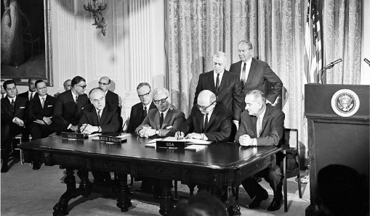
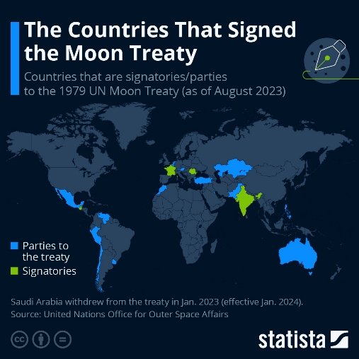
The questions began with the Outer Space Treaty in 1967, which hereby declared that “no nation could claim sovereignty over the Moon or other celestial bodies”. This basic ideal of shared space reflected the past situation of limited space activity and economic exploitation. In 1979, the Moon Agreement attempted to create a judiciary body to manage the future possibility of resource extraction. However, most major powers refused to join, fearing the possible restrictions on technological development. For years the issue remained purely theoretical, until in the early 2000s private spaceflight expanded and companies began seriously considering mining missions. New national laws in the 2010s in the United States and Luxembourg granted companies ownership of the materials that they removed from space. Introducing a new belief separating ownership and territorial claim. Surveys in the 2020s illustrated how a single metal-rich asteroid could contain more platinum than had ever been mined on Earth, sparking intense commercial competition. In the 2030s, limited access to the new mining technologies created disputes over fairness, justice and control. International negotiation stalled to create new regulations while commercial deals shaped the new norms. By 2080, space resources were vital to Earth’s economy, but no shared system determined who could claim or profit from them.
United Nations - signing of the Outer Space Treaty
This chart shows the countries that are signatories/parties to the 1979 Moon Treaty in August 2023
Current Situation/Discussion (2080)
In 2080, the global economy is dependent on materials that were extracted outside of Earth. From asteroid produced metal to water converted to fuel for space travel. A small circle of corporations and technologically superior countries control most mining sites. Whereas most countries participate as consumers. Legally, ownership of celestial territory is still rejected. Yet long-term contracts and safety zones function like normal. Economists issue warnings about how the divide could cause imbalance between the space-rich and poor nations. Researchers also fear how the unsanctioned extraction of resources could alter orbits of asteroids or destabilize unique ecosystems before they even develop. Efforts to create order and taxation systems have stalled as states disagree over who should pay and who should receive. Without a system, competition continues rampant, and many believe that the first generation of space wealth will define the political pecking order on Earth.
Some Questions to Consider
- Should space resources be private property or managed for all?
- How can developing nations share profits without having capacity?
- Is an International Space Resources Authority necessary?
- What environmental limits should exist on extraction?
- How should disputes over overlapping claims be resolved?

Bibliography
Bittencourt Neto, O. (2022). Space mining and global justice: The need for benefit sharing. Space Policy, 60, 101476. https://doi.org/10.1016/j.spacepol.2022.101476
Canadian Bar Association. (2024, September 11). Equity in the space frontier: The laws of commercial space mining and solutions for common benefit. Retrieved from https://cba.org/sections/air-and-space-law/resources/equity-in-the-space-frontier-the-laws-of-commercial-space-mining-and-solutions-for-common-benefit/
Hobe, S., & de Man, P. (2021). National legislation on space resources and the future of the non-appropriation principle. German Journal of Air and Space Law, 70(1), 1–25.
Jakhu, R., Pelton, J. N., & Nyampong, Y. O. M. (2017). Space mining and its regulation. Springer.
Space Generation Advisory Council. (2024). Space resource regulation: From national approaches to the need for a general framework. Retrieved from https://spacegeneration.org/space-resource-regulation-from-national-approaches-to-the-need-for-a-general-framework
Tronchetti, F. (2019). Legal aspects of space resource utilization. Journal of Space Law, 43(2), 201–230.
United Nations. (1967). Treaty on principles governing the activities in outer space. https://www.unoosa.org
United Nations Office for Outer Space Affairs. (2023). Space resources: Report of the Working Group on Legal Aspects. UNOOSA.

